Walk 18 Risbury Cross 2
Last walked in August 2017

Description. An 8 km (5 mile). A moderate ramble investigating country lanes, brooks and field paths, some quite testing. None of the gradients, which also visit the Humber and Holly brooks are too demanding.
Start. Explorer Map 202 Grid 571553.
Direction from Whitecross roundabout (Turn milometer to zero). Take the A4110 Canon Pyon (Three Elms road) for 1 mile and TR at the traffic lights onto the A4103 Worcester (Roman road). At the second roundabout, after 3.2 miles, TL towards Bodenham. At 9.5 miles at the T-junction TL towards Leominster. At 9.7 miles TR down Bowley Lane for Risbury. At 11.4 miles TR for Risbury. At the cross roads, [12 miles] TR towards Pencombe and after about 100m you can park on the L hand side, opposite ‘The Old Post Office’, and a red Post Box.

1. Risbury Cross. Walk back down the road and over the crossroads, westwards towards Stoke Prior and Leominster. Continue on past the derestricted speed limit sign and drop down the tree-canopied road. Continue along the road that bends to the R and goes up the hill to reach a T-junction. TR and descend to a pond that’s on your R, just beyond an old mill house.

2. Risbury Bridge. About 30m past the road bridge you TR and go thru a wooden gate into an orchard and walk along the brook that is on your R. TR and cross over a wooden bridge over the brook and into a small field. TL (the brook is on your L) and walk along the narrow field, thru some trees, along the narrow field to cross over a stile. Continue on thru (possibly nettled) copse, and out via a metal footbridge on your L, into F1. Bear R and walk across to the L field edge. Continue on up the L field edge to pass between the fence/wood and the ruined building called Gob’s Castle.

3. Gob’s Castle. 100m beyond the building you TL thru a waymarked metal gate into F2. Now go half R and over the crest of large field and down to cross a wooden stiled footbridge (in trees) and into F3. TL, go down to the field corner and continue on for about 20m to TR thru a metal gate and into a wooded area. Follow narrow path thru trees and bear L to exit trees via a gated concrete footbridge. TR, the track follows the stream for a couple of hundred metres then goes off to the L and up the bank to reach F4. Continue on around the cropped field, keeping to the R edge. Ignore the stile on you R and about 100m further on you TR thru a small wooden gate into F5. Go half L and across the field to cross a stile onto a road. Keep on the same line across the junction and go along the road towards Stoke Prior. At the cross roads by the Stoke Prior and the 30mph signs you TR and continue on towards the Stoke Prior School.

4. Blackwardine Crossroads. The road bears to the R and reaches a cross roads that you cross over and go straight ahead and down all the way to Humber Church. Opposite the church lych-gate you TL and go along a Public Bridleway to Humber Court Farm. The lane bends R and further on it bends L (metal gates and a stile are on the L), at this point you TR, and walk along a short (30m) farm track that bends L to reach a metal gate just beyond a barn on the L. Go thru the gate into F6 and bear R, to walk up the long pasture to reach the far L corner and go thru a waymarked metal gate into F7. Follow the L edge/hedge to cross over a wooden gated footbridge in the bottom L hand corner of this field into F8, (ignore any gates on your L).

5. Bridle Path. TL and walk along the L edge of a large field, Go thru a small wooden gate in the L hand corner into F9. Continue along the L edge of this field and go thru metal gate at the end, which is 30m in from the L corner into F10. Go straight ahead and across this field, and thru a metal gate into F11. Continue along the L edge of the next two fields (F11 & F12) and thru a metal gate onto a farmer track. Go up a bank and on thru another metal gate and along an enclosed farm lane, into Buckland farm buildings forecourt.

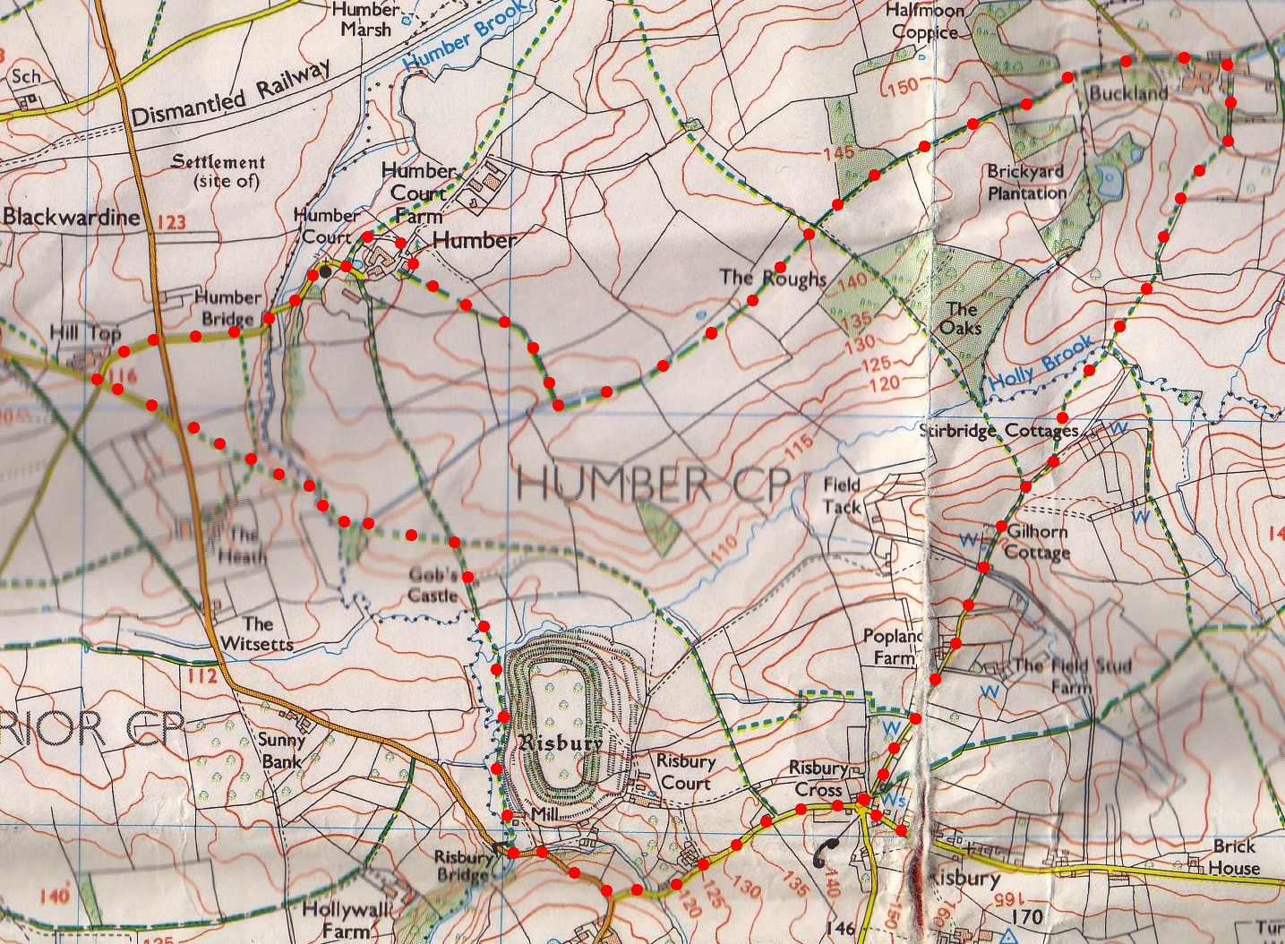
6. Buckland. 40 metres beyond a weather vane that’s on a roof to your R, TR (unsigned) and go down a farm track between barns and trees to go thru metal gate into F13. Bear R and pass just to the R of a hedge corner sticking out at you. Continue down the L field edge/hedge, and on thru a gate in the L corner and into F14. Descend quite sharply and head for the bottom R field corner, going just to the R of a lone tree. Cross Holly brook via a low bridge, and go thru two metal gates into F15. Climb the L edge of huge crop field and after about 350 metres cross a stile on your L, (the stile is opposite a lone tree).
3
4
5
6
7

7. “High” Stile. TR and continue on your original line up along old drovers’ lane. Just beyond a stile on your R (ignore) go thru farm gate, bear R by a grid (L) down a track past Gilhorn Cottage, up beyond “Rail Meadow” and Poplands to join surfaced track to Risbury Cross and start.
1
2

